**PUSL2010 Analysis**

**RANUL**

* The supermarket being a large network and operating daily requires a lot of capacity within the system handle numerous transactions without failure.
* As the business grows more and more data would be transferred and stored to keep the business in firmly stable with the competition, this requires new equipment to handle network traffic, faster storage drives, accurate GPS modules and more robust IPDS so as the requirements grow more space is required for them. Virtualization could help to overcome this problem in a more economical way sustaining the traditional servers within the chain.

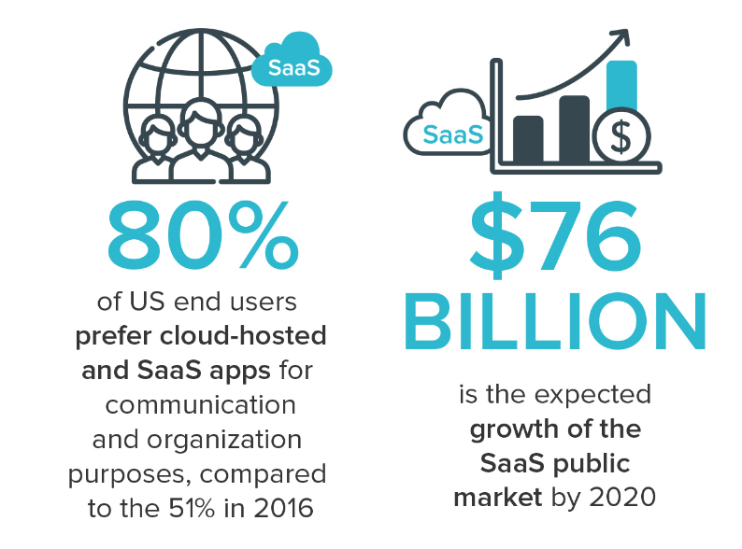

Figure 1: Illustration of trends for SaaS (AALPHA, 2020)

* Most business platforms today run on the Cloud, this helps to work on the go for staff and reduces extra store space required to store serves, and maintenance costs. Due to fact that most business move the SaaS model (Software as a Service), it will be profitable for the Supermarket chain to move the IT Infrastructure to the Cloud. (FinancesOnline, 2020)
* Upgrade will make expansions and future upgrades to the IT Infrastructure more flexible and safer from damages as personalized services as offered by partners businesses. If the Company requires to store company’s sensitive material, the old servers can be utilized for this, making the upgrade more economical and approachable to the company.
* Statistics show increasing trends for people requiring to work from home and for administrators requirements to maintain systems from one service point where actions can be assigned, monitored and controlled. This shows clear evidence for the requirement of the supermarket chain to move to cloud-based infrastructure as studies done by FlexJobs and Global Workplace Analytics shows “that there has been a major upward trend in the amount of people working remotely in the U.S. In the span of one year, from 2016 to 2017, remote work grew 7.9%. Over the last five years it grew 44% and over the previous 10 years it grew 91%. Between 2005 to 2017, there was a 159% increase in remote work. In 2015, 3.9 million U.S. workers were working remotely. Today that number is at 4.7 million, or 3.4% of the population.” (flexjobs, 2020)

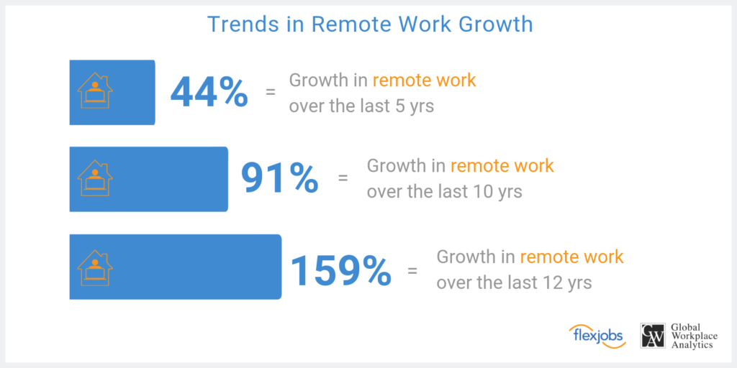

Figure 2: Illustration of Growth in Remote Work (flexjobs, 2020)

**LAHIRU**

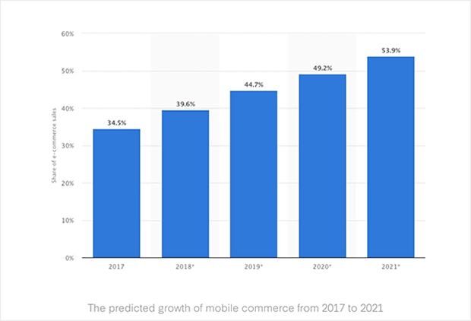As to the provide scenario in the assignment brief, this supermarket chain is planning to modernize their operations by tracking their goods’ statistics like quantity, sales rate, coordination of regional departments and to provide online shopping services. Day by day passes by the ratio of consumers buying their goods from online than attending to the store is raising gradually. So, companies should start providing their services via online to gain a profitable margin in the years to come. This interacts directly to providers like supermarket chains as they provide to extreme essentials people require daily.

*Figure 3: Illustration of Statistics Raising for Online Shopping (Ouellette, 2020)*

According to the future predictions of online shopping there will be 54% dominating the sales sector in 2021. This means half of the goods sold are either delivered to the buyer’s home or product is sent to a pick-up outlet. The main purpose for the majority interested in online shopping is due to the consumer time allocation to execute the task is less. But in terms of store shopping the instant interaction and purchase of goods is the beneficial perspective.

This supermarket chain’s main goal is to implement their own IT system and infrastructure to operate the supply chain efficiently and reliably. This brings to different perspectives in benefits and drawbacks for this supermarket chain.

Benefits:

* Data operated in the IT infrastructure is physically located under the supermarket chain’s supervision and full control over their data.
* Can instantly maintain the network and hardware equipment is necessary,
* There are less vendor limitations in further developing the IT infrastructure.
* Physical interaction to the hardware equipment will only be done by the organization’s trusted employees.

Drawbacks:

* Additional IT sector in the organization is required to monitor and maintain the network.
* More costly to run an IT infrastructure by the organization than handing over to a vendor due to the maintenance of constant usage in electricity, data bandwidth, and water. Monitoring and managing a network take a lot of resources as it’s an addition operating cycle for the organization. An IT infrastructure required for such organization requires servers, these servers are meant to be handled in certain environments like the temperature should be 19 to 24 degrees Celsius and the humidity should be at 70%. Backups systems like power back solutions, data backup solutions are required.
* High security threats and lack of experiences in handling such incidents.

These are just several benefits and drawbacks the organization would face after the installation of their own IT infrastructure.

And one drawback would be this IT infrastructure requires a tactical planning by professionals and hire skilled people to operate this new section of the daily operations. This is a crucial element as it leads to the outcome of the supply chain.

During this progression, the supermarket chain is planning to implement several functionalities,

* An option to shop online where consumers can receive the goods home delivered or collect it as a pick-up outlet.
* Quantity of goods available in the outlets and regional stores will be monitored and new stocks will be requested from the distributors.
* The monitoring and management of the supply chain will be handled by the head office of the supermarket chain 24/7.

They plan to implement such services by the use of IOT (Internet of Things) and GPS devices. Also, the security of network infrastructure will be secure as to the monitoring of the daily activities done in the supply chain.

**NIDULA**

In the project analysis we determine all the features and functionalities the project must accomplish along with all the risk that we may have to face during the duration of the project so in the analysis we must find these risk and come up with a solution if these risks occur in the future. Having the proper infrastructure is crucial as it provide services to end user so having a good infrastructure can help the organization and as the head of IT operations, we need to ensure that the customer services are satisfied.

**Objective of the project**

Our objective is to select a proper infrastructure which will provide more functionality than the current infrastructure that is being used. And from we must select a specific infrastructure and determine why it is better than the rest of the infrastructures, the options are traditional server deployment, virtualized deployment and in housed (on site) or off-site (ISP) based deployment.

**Details about the Infrastructure**

Each of these infrastructures has their own pros and cons and as the heads of IT operations it is our task to determine an infrastructure that is suitable for the organization. here is some information about each of these infrastructures which may be helpful when deciding an infrastructure for the business.

Traditional server deployment

The traditional server deployment has its pros and cons which may affect the decision of the infrastructure. Some of the pros are High performance and specialized hardware and another advantage is that. The disadvantages are inability to virtualize and expensive disaster recovery and these are only some of the drawbacks to this infrastructure and should be considered when choosing.

Virtualized deployment

Server virtualization is a software architecture that allows more than one server operating system to run as a guest on a given physical server host. Some of the virtualization platforms are VMware, Xen and KVM. The virtualized deployment has its pros and cons some of its pros are less maintenance cost, less physical server and less energy cost. But this infrastructure also has some cons sing point of failure and high stress on single machine. So, deciding whether this infrastructural is perfect for the business depend on the type of business and functionalities the business needs to provide to the customers.

In housed or off-site based deployment

This infrastructure also has its pros and cons when it is chosen Just like the other infrastructures. Some of its pros are that Gives you physical control over your backup, keeps critical data in-house so No third party has access to your information and No need to rely on an Internet connection for access to data. Then there are some disadvantages for this infrastructure, and they are Needs space in your workspace for a rack or server, dedicated IT support and No uptime or recovery time guarantees. So, it depends on the business whether this infrastructure in suitable to the business.

**Project success**

The project will be a success when the correct infrastructure is chosen and has a clear understanding why this specific infrastructure is better than the current and from the other options that were available and what are the new functionalities it will provide. In addition, the infrastructure should be implemented and completed within the given time period and the budget for the project to be successful.

**RYAN**

**ISHAN**

In the given scenario we must implement a supermarket infrastructure to make the current transactions efficient. The supermarket infrastructure consists of

* Sales outlets (supermarkets)

Provide shopping facilities to online and traditional Customers. The Online purchases will be delivered via transport or customers will be able to pick it from the nearest supermarket.

* Storage and logistic centers.

The stocks sent from farms will be stored here .Depending on the demand provide supermarkets with stocks.

* Transportation system

Transport goods from each outlet.

* Head office

Implement security via a command and control station.

Communicate to any outlet , security focal point via and AOIP .

Monitor every location via CCTV.

Track transportation via GPS and IOT .

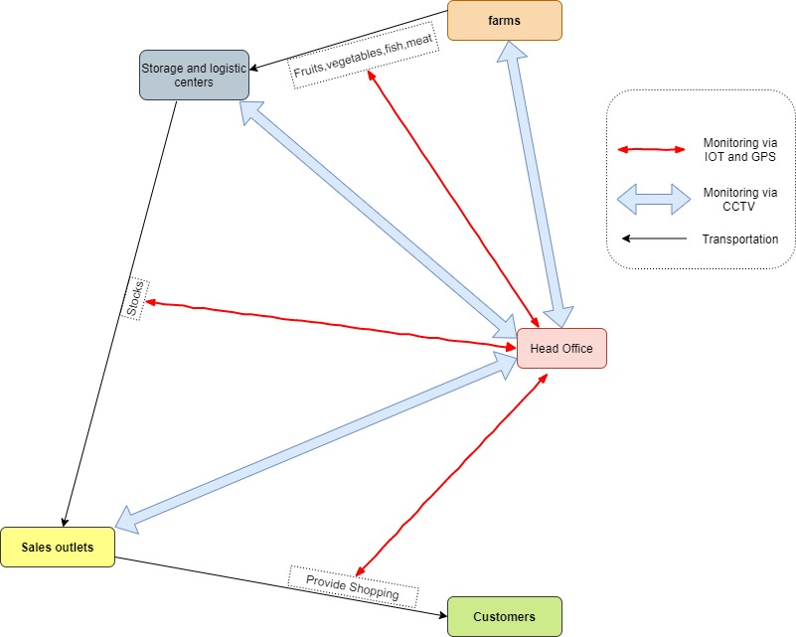

# Objective

Provide a detail proposal about all the possible infrastructure and decide the best cause the company should take to enhance their Supermarket chain system.

# Requirements

* Explain the possible infrastructures in detail (the technologies they use)
* Identify the External and internal users of the current system
* Compare each of these infrastructures with one another(Identify weaknesses and strength of each Infrastructure).
* The current trends / technologies used in Supermarket industry .
* Why the selected infrastructure is better to the given scenario() ?
* Diagrams of the implemented Infrastructure

**References**

AALPHA (2020) *saas users preference*. Available at: <https://www.aalpha.net/blog/how-to-develop-a-cloud-based-saas-application-software-product/attachment/saas-users-preference/> (Accessed: 02 April 2020).

FinancesOnline (2020) *62 SaaS Statistics You Must Learn: 2020 Market Share & Data Analysis*. Available at: <https://financesonline.com/saas-statistics/> (Accessed: 02 April 2020).

flexjobs (2020) *Remote Work Statistics: Shifting Norms and Expectations*. Available at: <https://www.flexjobs.com/blog/post/remote-work-statistics/> (Accessed: 03 April 2020).

Ouellette, C., 2020. *Online Shopping Statistics You Need To Know In 2020*. [online] OptinMonster. Available at: <https://optinmonster.com/online-shopping-statistics/> [Accessed 5 April 2020].